PROJECT REPORT

Data Science

**Project Title** - Predicting Company Profit using Regression Algorithms

|  |  |
| --- | --- |
| **Submitted By:** | Ananya Pareek |
| **Submitted To:** | Exposys Data Labs |
| **Email ID:** | pareek.ananya1@gmail.com |
| **Contact No:** | 7976584329 |

**ABSTRACT**

This report meticulously explores the process of predicting company profit utilizing advanced machine learning regression algorithms. Through a comprehensive analysis of a dataset comprising crucial information on R&D Spend, Administration Cost, Marketing Spend, and Profit for 50 companies, various regression algorithms are meticulously implemented and rigorously evaluated. The objective is to discern the most accurate model for profit prediction, thereby providing invaluable insights for businesses striving to optimize operations and enhance profitability. Leveraging the power of machine learning, this project aims to construct predictive models that offer actionable insights to drive growth and success. The proposed methodology encompasses a repertoire of regression algorithms, each endowed with unique architectural intricacies and predictive prowess. From the simplicity of Linear Regression to the complexity of ensemble methods such as Random Forest Regression and AdaBoost, our approach aims to capture the intricate relationships between input variables and company profit. Through meticulous experimentation and evaluation, we aim to unearth the optimal model that seamlessly aligns with the unique characteristics of the dataset, facilitating precise and reliable profit predictions. By providing businesses with actionable insights, this project seeks to empower organizations to make informed decisions and strategically allocate resources, thereby maximizing profitability and fostering sustainable growth.

*Keywords: Company Profit, Machine Learning, Regression Algorithms, R&D Spend, Administration Cost, Marketing Spend, Profit Prediction, Optimization, Decision-Making, Ensemble Methods, Linear Regression, Random Forest Regression, AdaBoost.*

**Table of Contents**

|  |  |  |  |
| --- | --- | --- | --- |
| **S.No** | **Contents** | | **Page No.** |
| 1. | Introduction | | 4 |
| 2. | Existing Methods | | 4 |
| 3. | Proposed Method with Architecture | | 4 |
| 4. | Methodology | | 5 |
| 4.1 | Data Pre-processing………… | 5 |
| 4.2 | Data Visualization………….. | 5 |
| 5. | Implementation | | 7 |
| 6. | Conclusion | | 8 |

1. **Introduction:**

Predicting company profit stands at the core of strategic planning and decision-making for businesses across industries. By unravelling the intricate interplay between factors such as R&D Spend, Administration Cost, Marketing Spend, and Profit, companies can attain a profound understanding of their operational dynamics, enabling them to strategically allocate resources and maximize profitability. This project endeavours to leverage the power of machine learning to construct predictive models that accurately forecast company profit based on available data, thereby empowering businesses with actionable insights to drive growth and success.

1. **Existing Methods:**

Drawing upon the wealth of knowledge amassed in the field of machine learning and predictive analytics, previous studies have extensively explored various regression algorithms for profit prediction tasks. Linear Regression, Decision Trees, Random Forest Regression, AdaBoost, and XGBoost are among the prominent algorithms that have been employed in similar contexts, serving as invaluable benchmarks for our project. By scrutinizing the performance and efficacy of these algorithms in diverse scenarios, we gain invaluable insights into their applicability and potential for accurately forecasting company profit.

1. **Proposed Method with Architecture:**

In our pursuit of developing robust predictive models for profit prediction, we propose to explore and implement a repertoire of regression algorithms, each endowed with its unique architectural intricacies and predictive prowess. From the simplicity of Linear Regression to the complexity of ensemble methods such as Random Forest Regression and AdaBoost, our methodology encompasses a comprehensive spectrum of techniques aimed at capturing the intricate relationships between input variables and company profit. Through meticulous experimentation and evaluation, we endeavour to unearth the optimal model that seamlessly aligns with the unique characteristics of our dataset, thereby facilitating precise and reliable profit predictions.

1. **Methodology:**
   1. **Data Pre-processing:**

* The initial phase entails loading the dataset and conducting a meticulous inspection to identify any missing values or anomalies.
* Missing values are meticulously imputed using appropriate strategies, ensuring the integrity and completeness of the dataset.
* Outliers, which may exert undue influence on model performance, are identified and treated using robust techniques such as the Interquartile Range (IQR) method.
* Categorical variables are meticulously encoded to numeric representations, facilitating seamless integration into the machine learning models.
* Continuous variables are subjected to logarithmic transformation to mitigate skewness and ensure adherence to the assumptions of linear regression.
  1. **Data Visualization:**

The visualization phase plays a pivotal role in unravelling the intricate relationships between variables and gaining profound insights into the underlying patterns within the data.

* + 1. 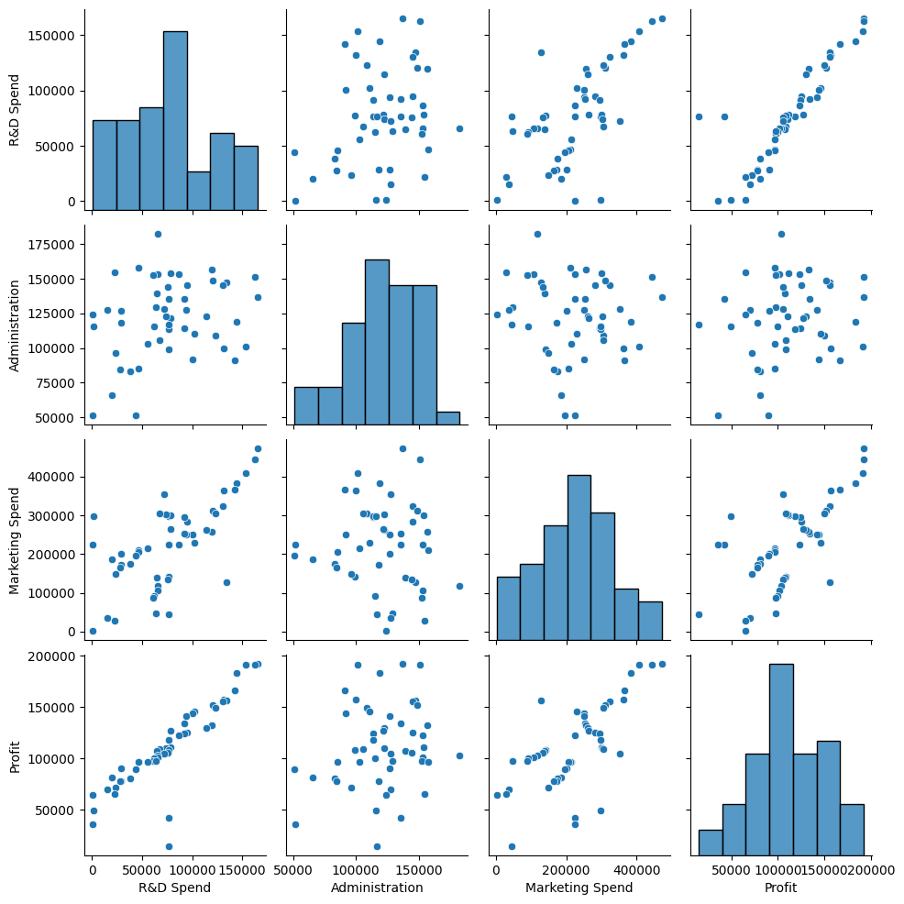Pairplot: A comprehensive pairwise visualization facilitates the exploration of relationships between multiple variables, offering invaluable insights into potential correlations and trends.
    2. 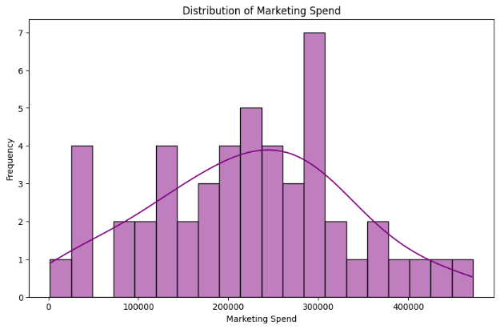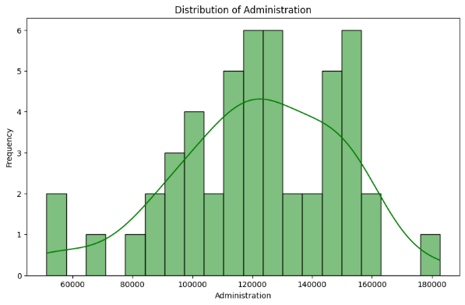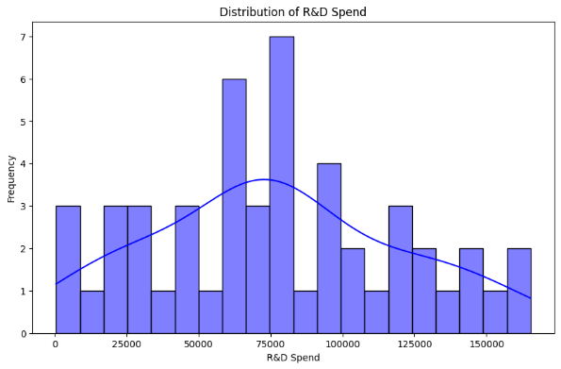Histograms: By visualizing the distribution of R&D Spend, Administration, and Marketing Spend, histograms provide a vivid depiction of the underlying data distribution, shedding light on potential outliers and anomalies.
    3. 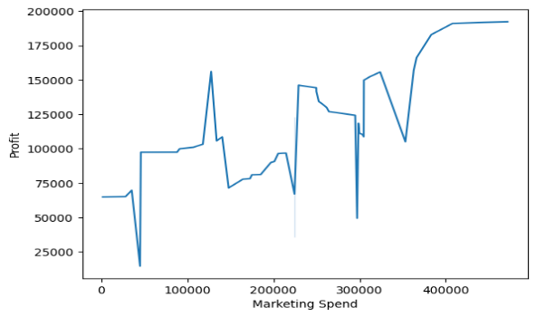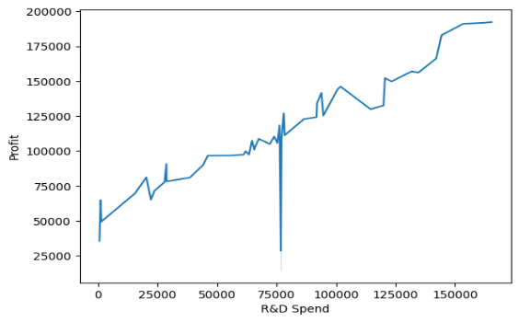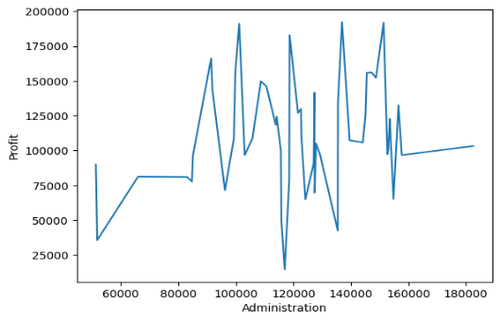Line Plots: These plots depict the relationship between each independent variable and Profit, offering a nuanced understanding of how variations in input variables impact the target variable.
    4. 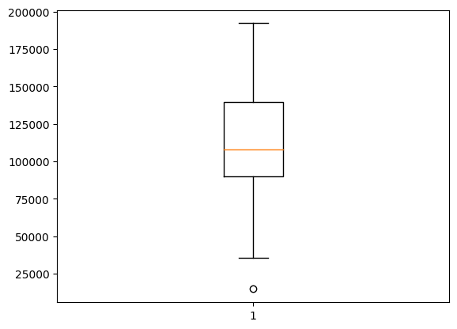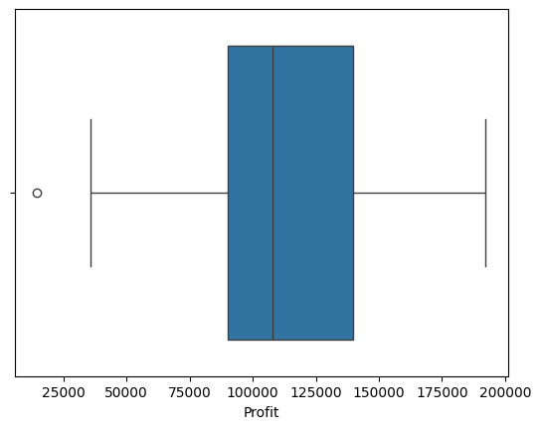Boxplots: Utilized to identify outliers within the Profit column, boxplots offer a comprehensive visualization of the distribution of data points, enabling the identification and treatment of outliers.
    5. Heatmap: A visual representation of the correlation matrix provides invaluable insights into the strength and direction of relationships between variables, guiding feature selection and model development.

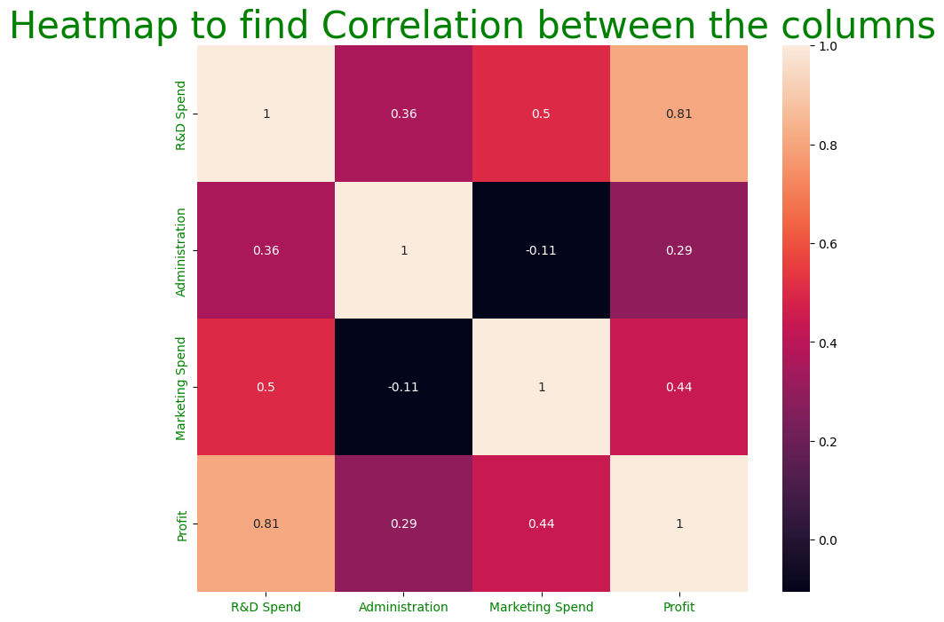

1. **Implementation:**

The implementation phase encompasses the seamless integration of the proposed methodology into a cohesive and scalable framework, leveraging the rich ecosystem of Python programming language and libraries such as Pandas, NumPy, Seaborn, Matplotlib, and Scikit-learn. The codebase is meticulously structured into modular components, encompassing data pre-processing, model training, evaluation, and comparison. The version details for the libraries employed in the implementation are as follows:

* Pandas 1.5
* NumPy 1.20
* Scikit-learn 0.24
* Seaborn 0.11
* Matplotlib 3.4

1. **Conclusion:**

In conclusion, this project represents a seminal endeavour to develop accurate and reliable predictive models for company profit prediction. Through a systematic exploration of diverse regression algorithms and meticulous evaluation of their performance, the AdaBoost regressor emerges as the optimal model, exhibiting superior predictive accuracy and robustness. With an impressive R-squared score, the AdaBoost regressor holds immense potential to empower businesses with actionable insights, enabling them to navigate the dynamic landscape of modern commerce with confidence and foresight.